DBMS2 - FINAL PROJECT

RESOURCES: <https://www.kaggle.com/ekrembayar/fifa-21-complete-player-dataset>

GIT HUB

FRONT END & BACK END: <https://github.com/rooohaa/dbms-project.git>

DATABASE: <https://github.com/MukhammedAli/dbms-project-database.git>

This project is about displaying information of football players and manipulating some data by using insert/update/delete operations. We took some style of analyzing data and displaying it to client from famous fifa players record. As you can see in the front end part, on the main page it gives ability to see all players based by their id’s which contains personal information about them. Also if client wants to find special data about player it is possible to search by using input button. In addition , we’ve completed bonus task where we need to add recommendation . Every time when client interacts with application by using DML statements our display table will change . Sorting and graph processing are done in our project . Under the hood of this software we’ve used modern new technologies like React.js library on frontend , NodeJs + Express for backend side, also Chart.js library to construct specific graphs, charts from our data and Oracle database which builds main logic for our application.

Let’s dive into the main core of our project , that is oracle implementation.

ATTENTION: All requirements are fulfilled, except image processing.

For this project we use two tables. The main table is datasetfinal which contains more than 500 rows and 10 columns. And second one is recommendation table which servers as bonus part of our project implementation. By the way recommendation table has the same construct . DATASETFINAL contains numeric , varchar2 data types . Player_id has primary key constraint.

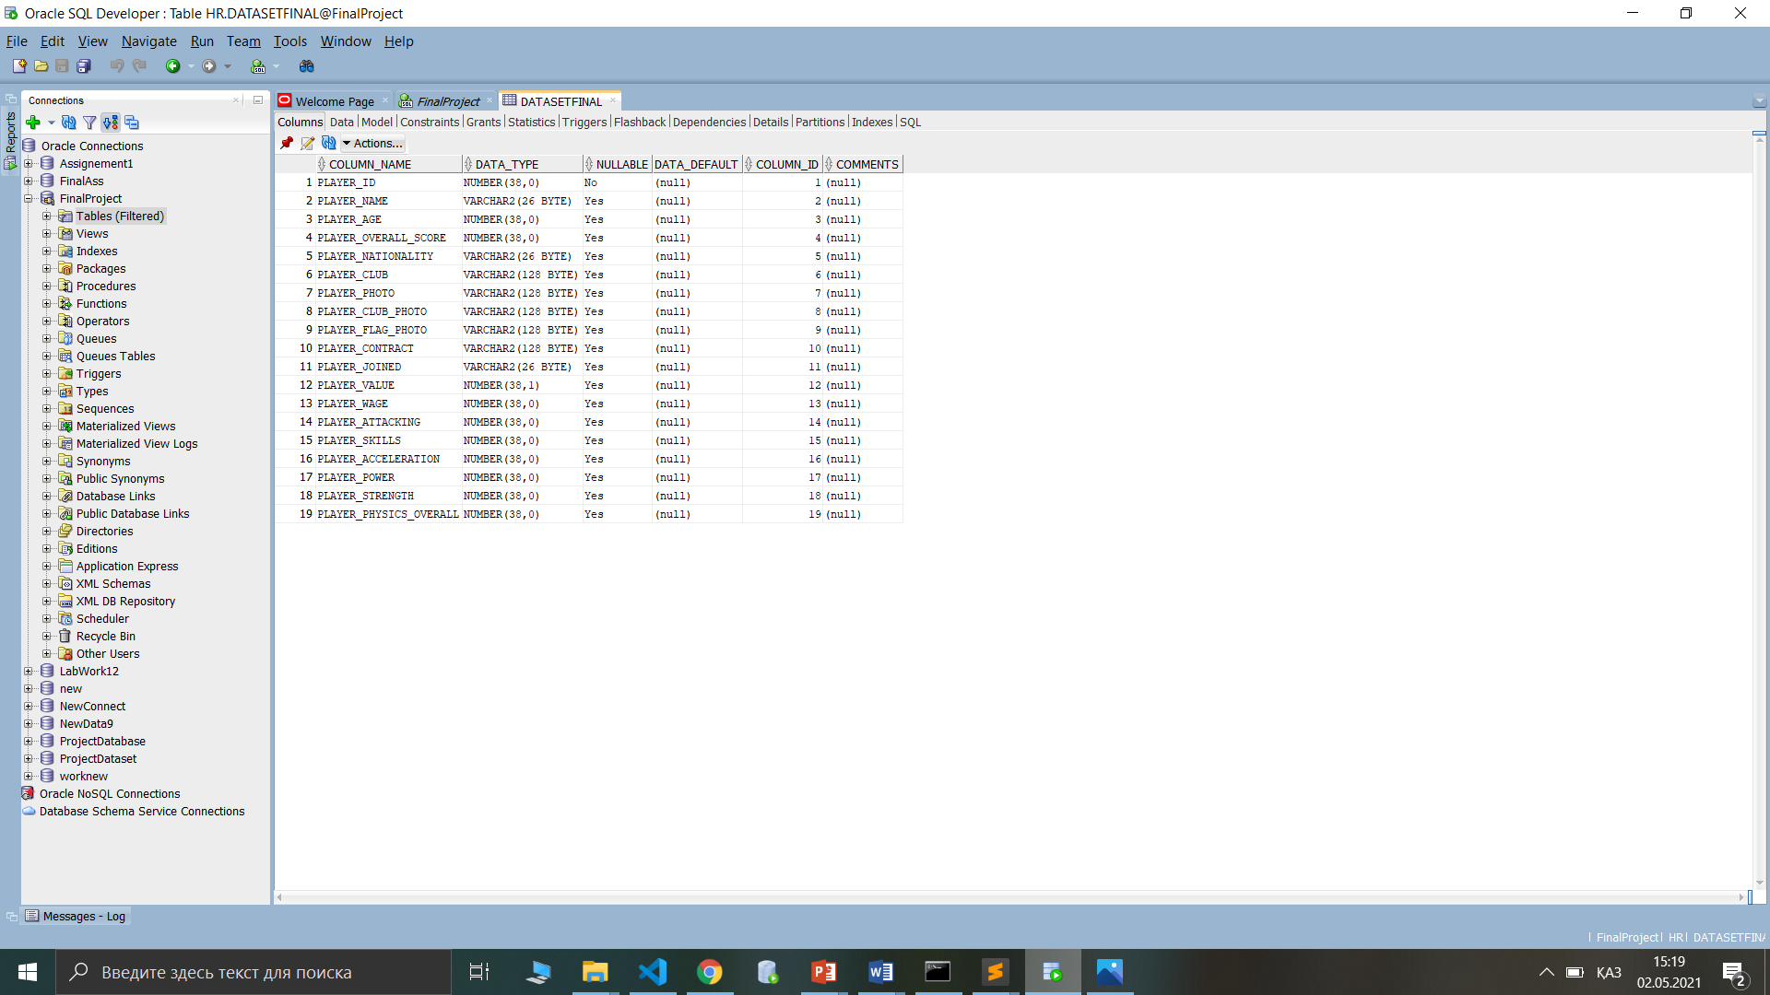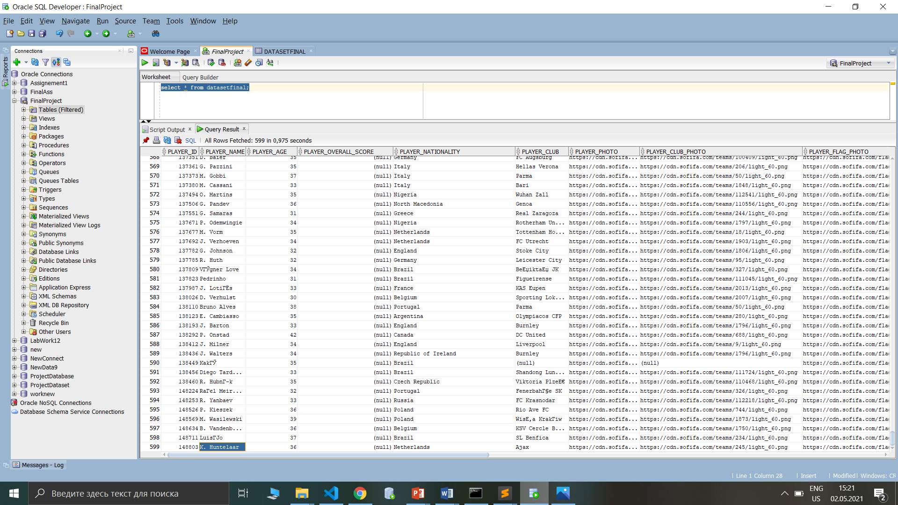

--FIRST PACKAGE

create or replace package first_package as

procedure create_index;

cursor help_cursor is select player_id , player_attacking ,

player_skills from datasetfinal;

new_rec help_cursor%rowtype;

type t_newtype is table of help_cursor%rowtype

index by binary_integer;

new_record t_newtype;

v_var number;

end first_package;

create or replace package body first_package as

procedure create_index

as

begin

open help_cursor;

loop

fetch help_cursor into new_rec;

new_record(new_rec.player_id):= new_rec;

exit when help_cursor%notfound;

end loop;

close help_cursor;

for i in new_record.first .. new_record.last

loop

if(new_record.exists(i))

then

v_var := new_record(i).player_attacking +

new_record(i).player_skills;

update datasetfinal

set player_overall_score = v_var where player_id = new_record(i).player_id;

end if;

end loop;

end create_index;

end first_package;

first_package contains create_index procedure , help_cursor and index by table of records which initialized as new_record.

The main purpose of this package is computing first derived column called PLAYER_OVERALL_SCORE . This column is summation of two single columns which are player_attacking and player_skills . These columns are represented as OVA column in front part’s table .By making some population and initialization staff at the end we will be able to sum up all necessary columns and update our datasetfinals table in appropriate places.

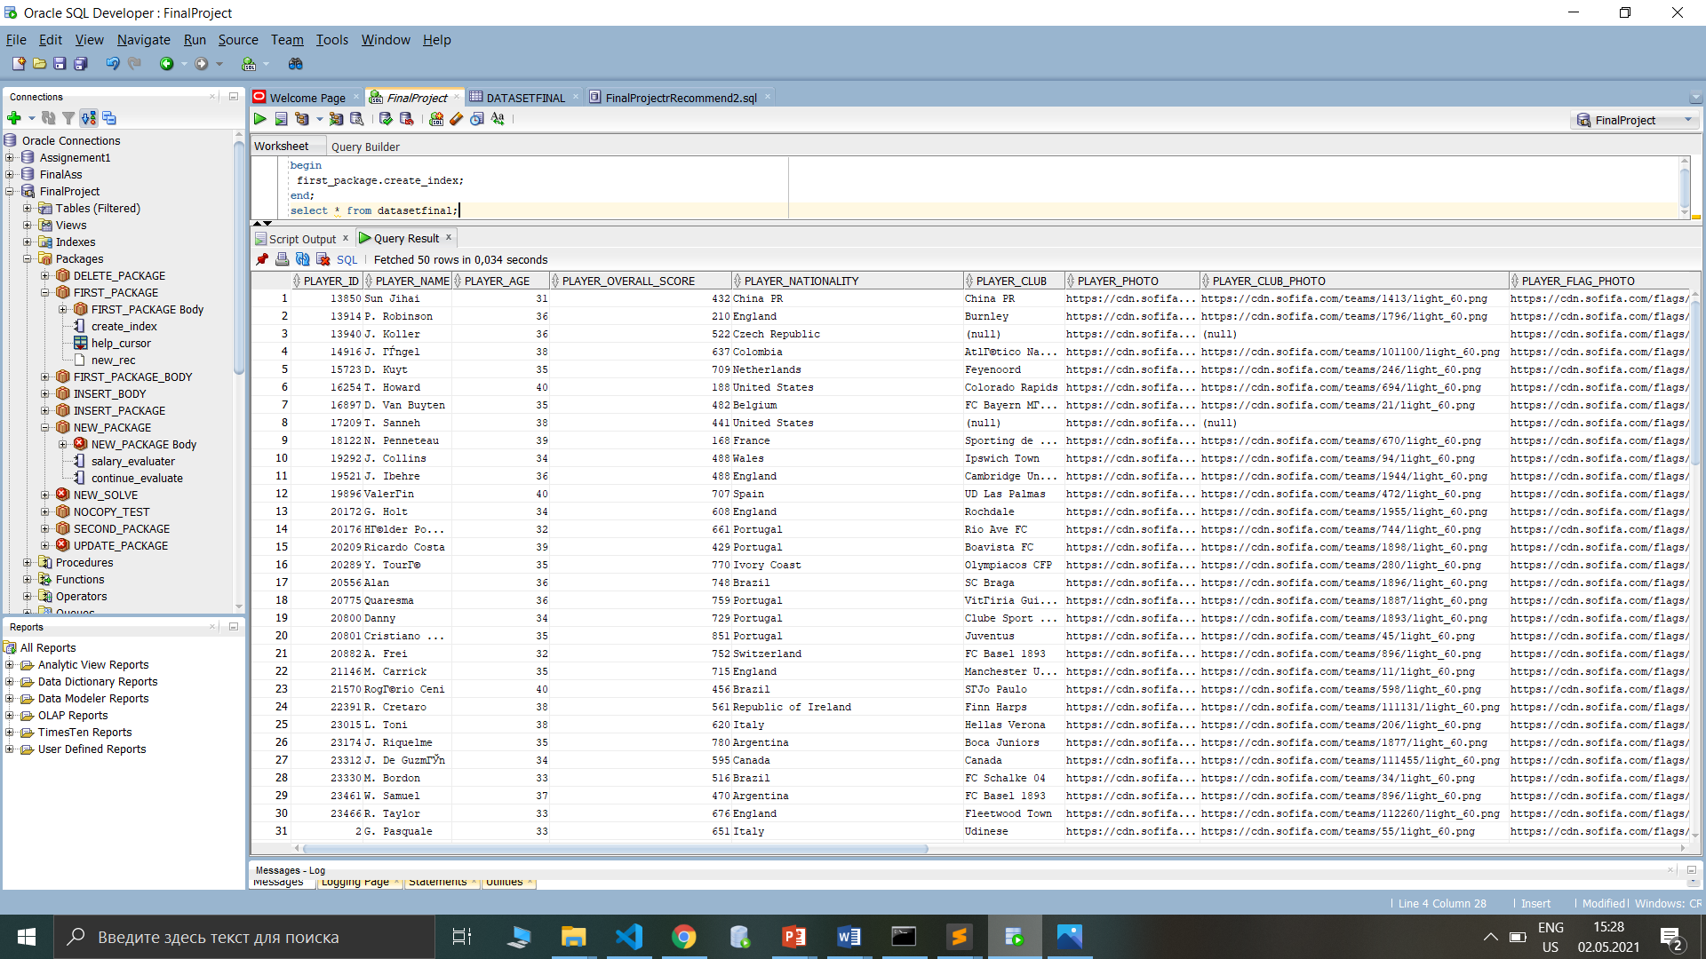

--SECOND PACKAGE

create or replace package second_package as

procedure create_physic;

cursor physic_cursor is select player_id , player_acceleration ,

player_power, player_strength from datasetfinal;

new_col physic_cursor%rowtype;

type t_physictype is table of physic_cursor%rowtype

index by binary_integer;

physic_record t_physictype;

v_var number;

end second_package;

create or replace package body second_package as

procedure create_physic

as

begin

open physic_cursor;

loop

fetch physic_cursor into new_col;

physic_record(new_col.player_id):= new_col;

exit when physic_cursor%notfound;

end loop;

close physic_cursor;

for i in physic_record.first .. physic_record.last

loop

if(physic_record.exists(i))

then

v_var := physic_record(i).player_acceleration +

physic_record(i).player_power + physic_record(i).player_strength;

update datasetfinal

set player_physics_overall = v_var where player_id = physic_record(i).player_id;

end if;

end loop;

end create_physic;

end second_package;

The second package uses the same technology as in the previous package except that here we compute PLAYER_PHYSICS_OVERALL which is the second derived column. The structure is the same at first glance. We use player_acceleration , player_power , player_strength and sum up them into single derived column.

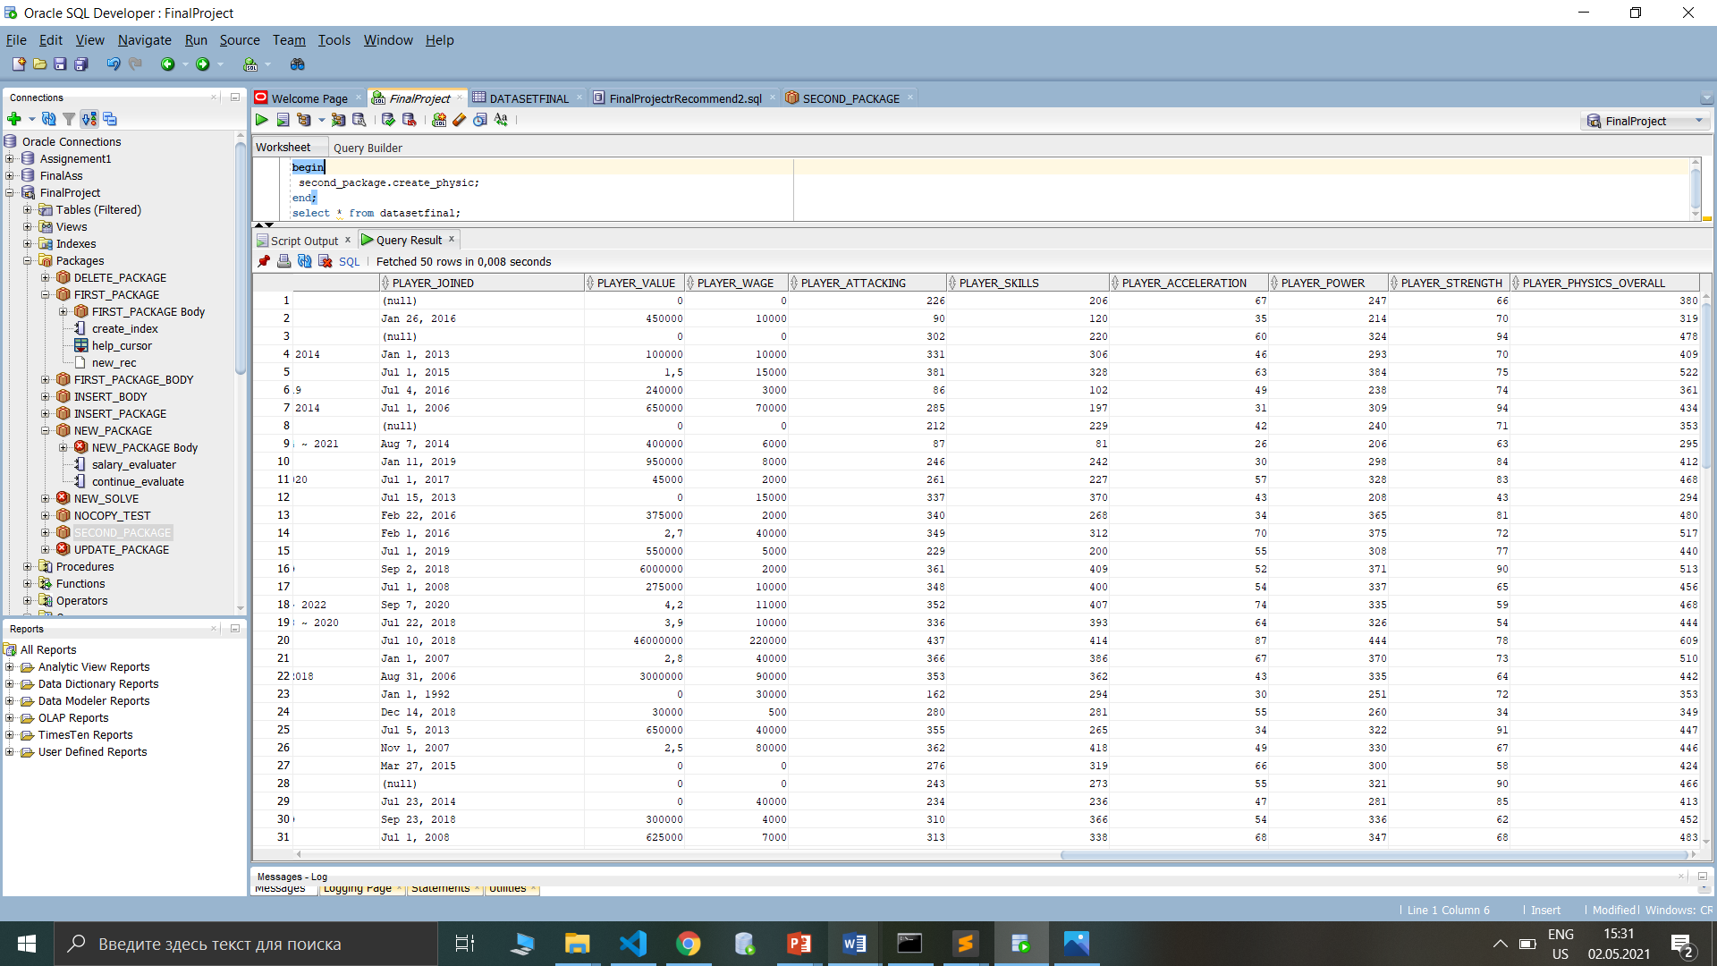

Of course, since we are filling derived columns we need some triggers to autocomplete each new changes.

--FIRST TRIGER

create or replace trigger after_insert_player

after insert on datasetfinal

begin

first_package.create_index;

second_package.create_physic;

end;

--SECOND TRIGGER

create or replace trigger after_update_player

after update of player_id,

player_name, player_age,

player_nationality, player_club,

player_contract, player_joined,

player_value, player_wage,

player_attacking, player_skills,

player_acceleration, player_power,

player_strength on datasetfinal

begin

first_package.create_index;

second_package.create_physic;

end;

These two triggers are responsible for fulfilling derived columns. Each time when we insert some new record or make changes they will fire and call necessary packages to sum up all appropriate columns.

In the next explanation you’ll see basic operations which gives ability to client manipulate with data by calling ready procedures. All of them contains DYNAMIC SQL so that by making insert/update/delete we’ve tried to use it .

--THIRD PACKAGE INSERT PACKAGE

create or replace package insert_package as

procedure insert_procedure(new_id datasetfinal.player_id%type, new_name datasetfinal.player_name%type,

new_age datasetfinal.player_age%type, new_nation datasetfinal.player_nationality%type, new_club datasetfinal.player_club%type,

new_contract datasetfinal.player_contract%type, new_join datasetfinal.player_joined%type, new_value_salary datasetfinal.player_value%type,

new_wage datasetfinal.player_wage%type, new_attacking datasetfinal.player_attacking%type, new_skills datasetfinal.player_skills%type,

new_acceleration datasetfinal.player_acceleration%type, new_power datasetfinal.player_power%type, new_strength datasetfinal.player_strength%type);

end insert_package;

create or replace package body insert_package as

procedure insert_procedure(new_id datasetfinal.player_id%type, new_name datasetfinal.player_name%type,

new_age datasetfinal.player_age%type, new_nation datasetfinal.player_nationality%type, new_club datasetfinal.player_club%type,

new_contract datasetfinal.player_contract%type, new_join datasetfinal.player_joined%type, new_value_salary datasetfinal.player_value%type,

new_wage datasetfinal.player_wage%type, new_attacking datasetfinal.player_attacking%type, new_skills datasetfinal.player_skills%type,

new_acceleration datasetfinal.player_acceleration%type, new_power datasetfinal.player_power%type, new_strength datasetfinal.player_strength%type)

as

v_execute varchar2(10000);

begin

v_execute := 'INSERT INTO ' || 'DATASETFINAL ' || '(player_id, player_name, player_age, player_nationality,

player_club, player_contract, player_joined, player_value, player_wage, player_attacking, player_skills,

player_acceleration, player_power, player_strength)' || ' VALUES' || '(' || new_id ||

' , ' || '''' || new_name || '''' || ' , ' || new_age || ' , ' || '''' || new_nation || ''''

|| ' , ' || '''' || new_club || '''' || ' , ' || '''' || new_contract || '''' || ' , ' || '''' || new_join ||

'''' || ' , ' || new_value_salary || ' , ' || new_wage || ' , ' || new_attacking || ' , ' || new_skills ||

' , ' || new_acceleration || ' , ' || new_power || ' , ' || new_strength ||')';

execute immediate v_execute;

end insert_procedure;

end insert_package;

This package contains insert procedure which is done by DYNAMIC SQL statement. If client wants to insert some new data it is easy to call ready procedure from oracle. From back end side we put necessary parameters and call it.

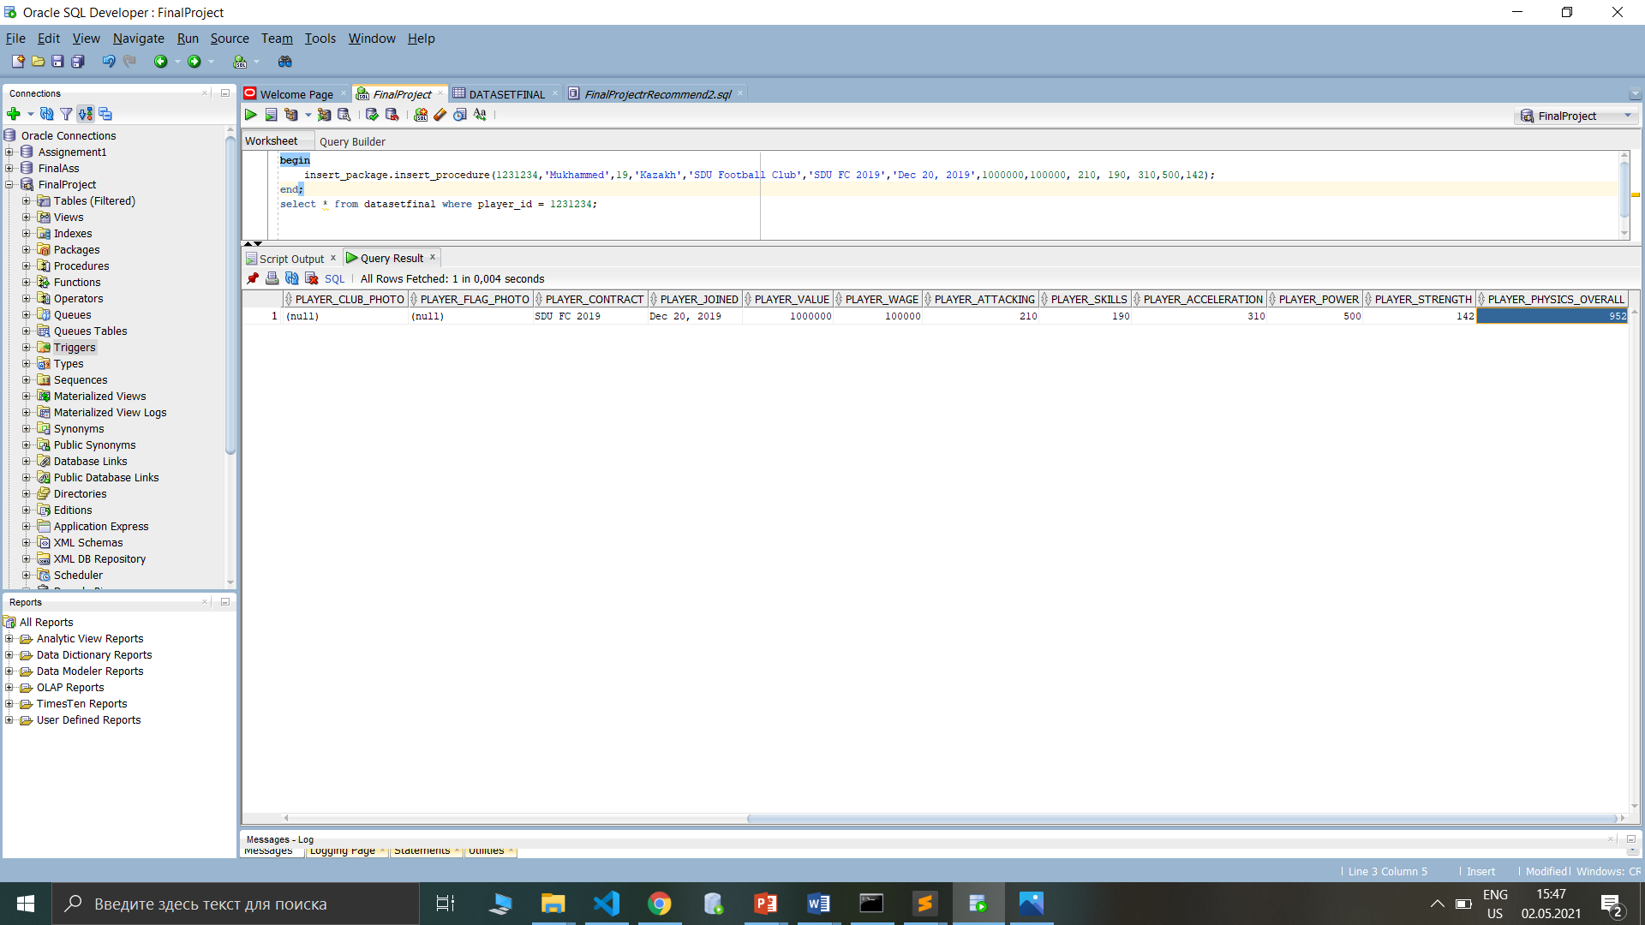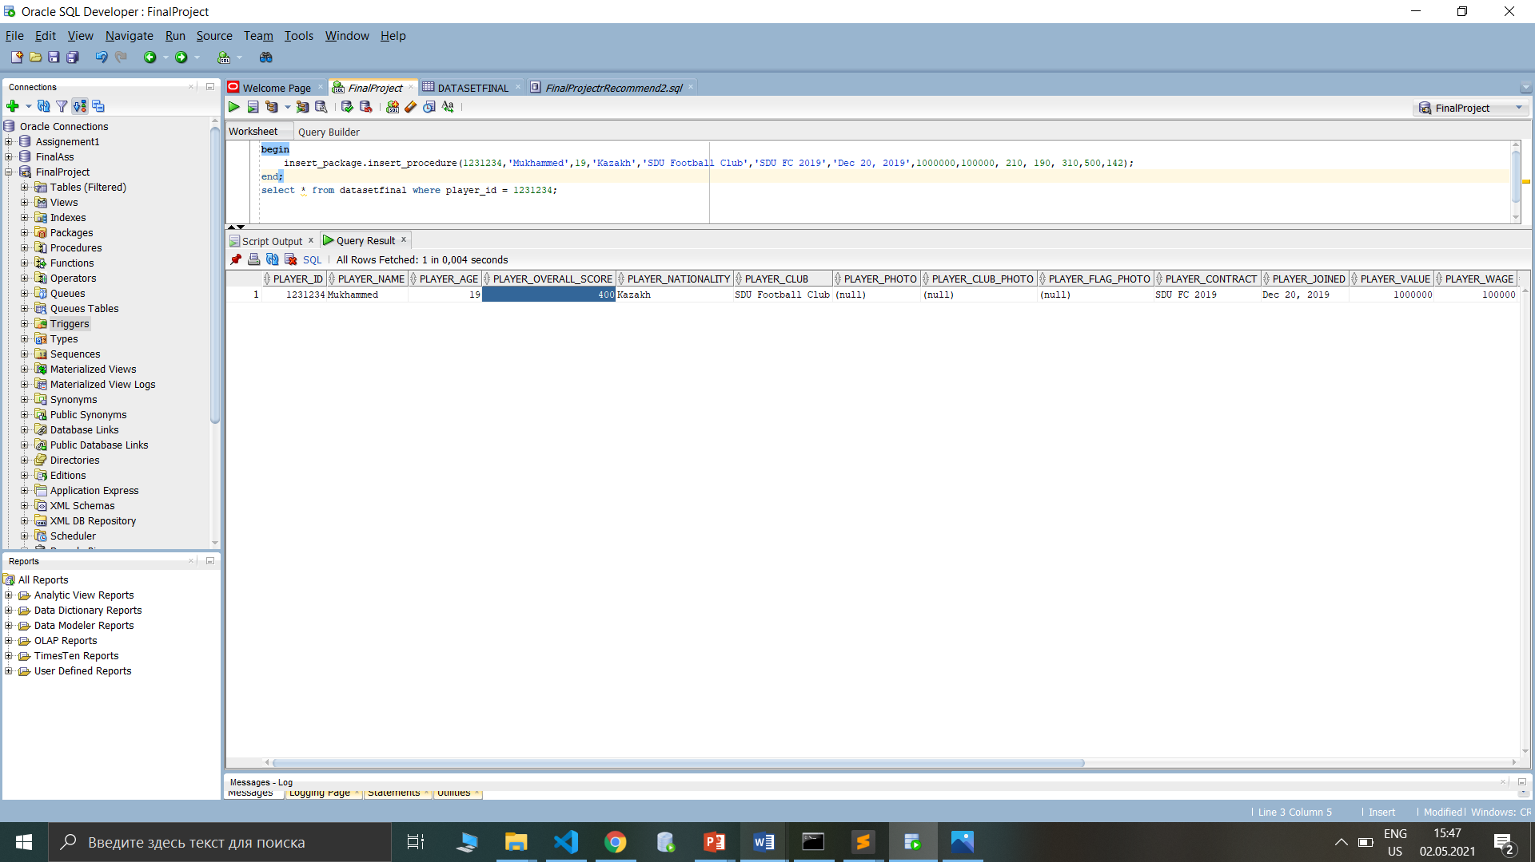

So also as you can notice , we didn’t insert derived columns. Instead of it we just compute them automatically by two triggers . The first trigger is for insert procedure and second one is for update .

--FOURTH PACKAGE UPDATE PACKAGE

create or replace package update_package as

procedure update_procedure(new_id datasetfinal.player_id%type, new_name datasetfinal.player_name%type,

new_age datasetfinal.player_age%type, new_nation datasetfinal.player_nationality%type, new_club datasetfinal.player_club%type,

new_contract datasetfinal.player_contract%type, new_join datasetfinal.player_joined%type, new_value_salary datasetfinal.player_value%type,

new_wage datasetfinal.player_wage%type, new_attacking datasetfinal.player_attacking%type, new_skills datasetfinal.player_skills%type,

new_acceleration datasetfinal.player_acceleration%type, new_power datasetfinal.player_power%type, new_strength datasetfinal.player_strength%type);

end update_package;

create or replace package body update_package as

procedure update_procedure(new_id datasetfinal.player_id%type, new_name datasetfinal.player_name%type,

new_age datasetfinal.player_age%type, new_nation datasetfinal.player_nationality%type, new_club datasetfinal.player_club%type,

new_contract datasetfinal.player_contract%type, new_join datasetfinal.player_joined%type, new_value_salary datasetfinal.player_value%type,

new_wage datasetfinal.player_wage%type, new_attacking datasetfinal.player_attacking%type, new_skills datasetfinal.player_skills%type,

new_acceleration datasetfinal.player_acceleration%type, new_power datasetfinal.player_power%type, new_strength datasetfinal.player_strength%type)

as

v_string_store varchar(10000);

begin

v_string_store := 'UPDATE ' || 'DATASETFINAL ' || 'SET ' || 'player_name' || ' = ' || '''' || new_name || '''' || ' , '

|| 'player_age' || ' = ' || new_age || ' , ' || 'player_nationality' || ' = ' || '''' || new_nation || '''' || ' , ' ||

'player_club' || ' = ' || '''' || new_club || '''' || ' , ' || 'player_contract' || ' = ' || '''' || new_contract || '''' || ' , ' ||

'player_joined' || ' = ' || '''' || new_join || '''' || ' , ' || 'player_value' || ' = ' || new_value_salary || ' , ' ||

'player_wage' || ' = ' || new_wage || ' , ' || 'player_attacking' || ' = ' || new_attacking || ' , ' ||

'player_skills' || ' = ' || new_skills || ' , ' || 'player_acceleration' || ' = ' || new_acceleration || ' , ' ||

'player_power' || ' = ' || new_power || ' , ' || 'player_strength' || ' = ' || new_strength || ' WHERE ' || 'player_id' || ' = ' || new_id;

execute immediate v_string_store;

end update_procedure;

end update_package;

UPDATE PACKAGE has the same structure as insert package. It also uses update procedure which includes DYNAMIC SQL .

--FIFTH PACKAGE DELETE PACKAGE

create or replace package delete_package

as

procedure delete_procedure(p_del_id datasetfinal.player_id%type);

end delete_package;

create or replace package body delete_package as

procedure delete_procedure(p_del_id datasetfinal.player_id%type)

is

v_new_st varchar(10000);

begin

v_new_st := 'DELETE ' || 'FROM' || ' DATASETFINAL ' || 'WHERE' || ' player_id ' || ' = ' || p_del_id;

execute immediate v_new_st;

end delete_procedure;

end delete_package;

DELETE PACKAGE CONTAINS delete procedure which takes id as parameter and executes some delete operation by DYNAMIC SQL;

--NEW SOLVE PACKAGE FOR FIXING PLAYER_VALUE AND PLAYER_WAGE

create or replace package new_solve as

cursor change_value

is select player_id, player_value

from datasetfinal

where player_value like '%,%';

cursor change_wage

is select player_id , player_wage

from datasetfinal

where player_wage like '%,%';

procedure change_procedure;

end new_solve;

create or replace package body new_solve as

procedure change_procedure is

begin

for temp_cursor in change_value loop

update datasetfinal set datasetfinal.player_value = temp_cursor.player_value * 1000000

where datasetfinal.player_id = temp_cursor.player_id;

end loop;

for temp_cursor in change_wage loop

update datasetfinal set datasetfinal.player_wage = temp_cursor.player_wage * 1000000

where datasetfinal.player_id = temp_cursor.player_id;

end loop;

end change_procedure;

end new_solve;

PLAYER_VALUE is the cost of player at certain football club. And PLAYER_WAGE is salary of player per each months. Our dataset contains integers and floats in these columns , represented by number data type. In addition , we noticed a little bug which removes zero digits at the end of floating point numbers. To prevent some errors and inconveniences , we’ve decided to make some special package with procedure , so we can see the clear data in our front part. Generally , the feature of this procedure is fixing our special bug. By using cursors and DML statements we multiplied cut zeroes to floating point numbers. Actually, procedure is just for our database part for consistency and clarification . Besides , client will be confused unless there is any clear data.

BEFORE NEW SOLVE

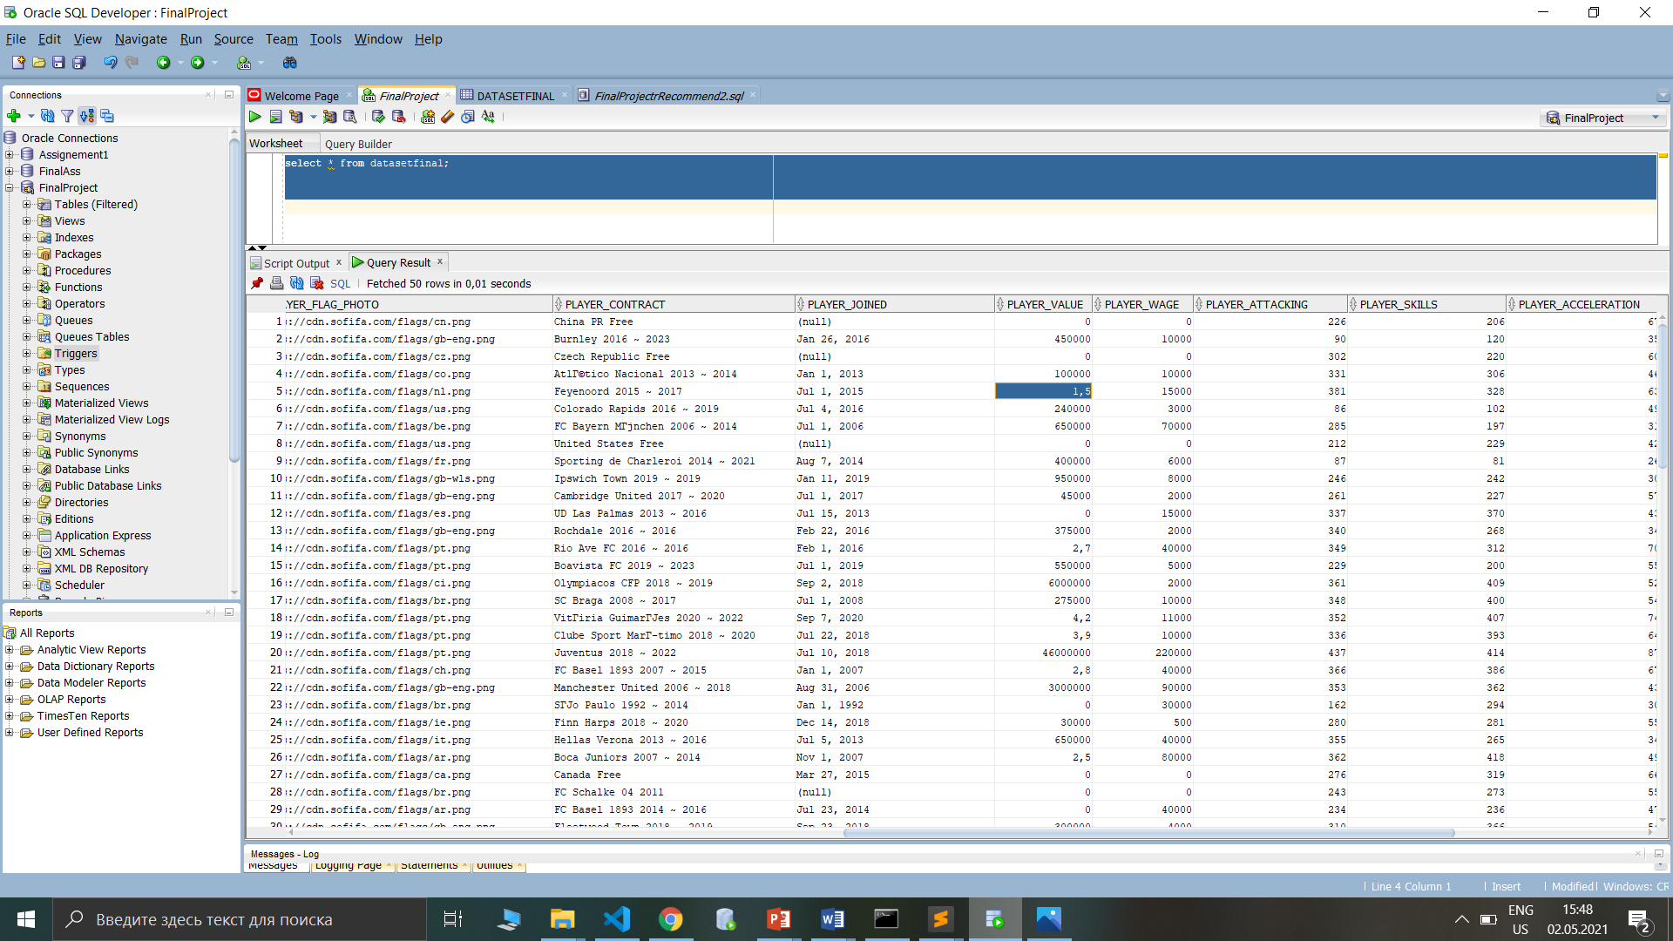

AFTER NEW SOLVE

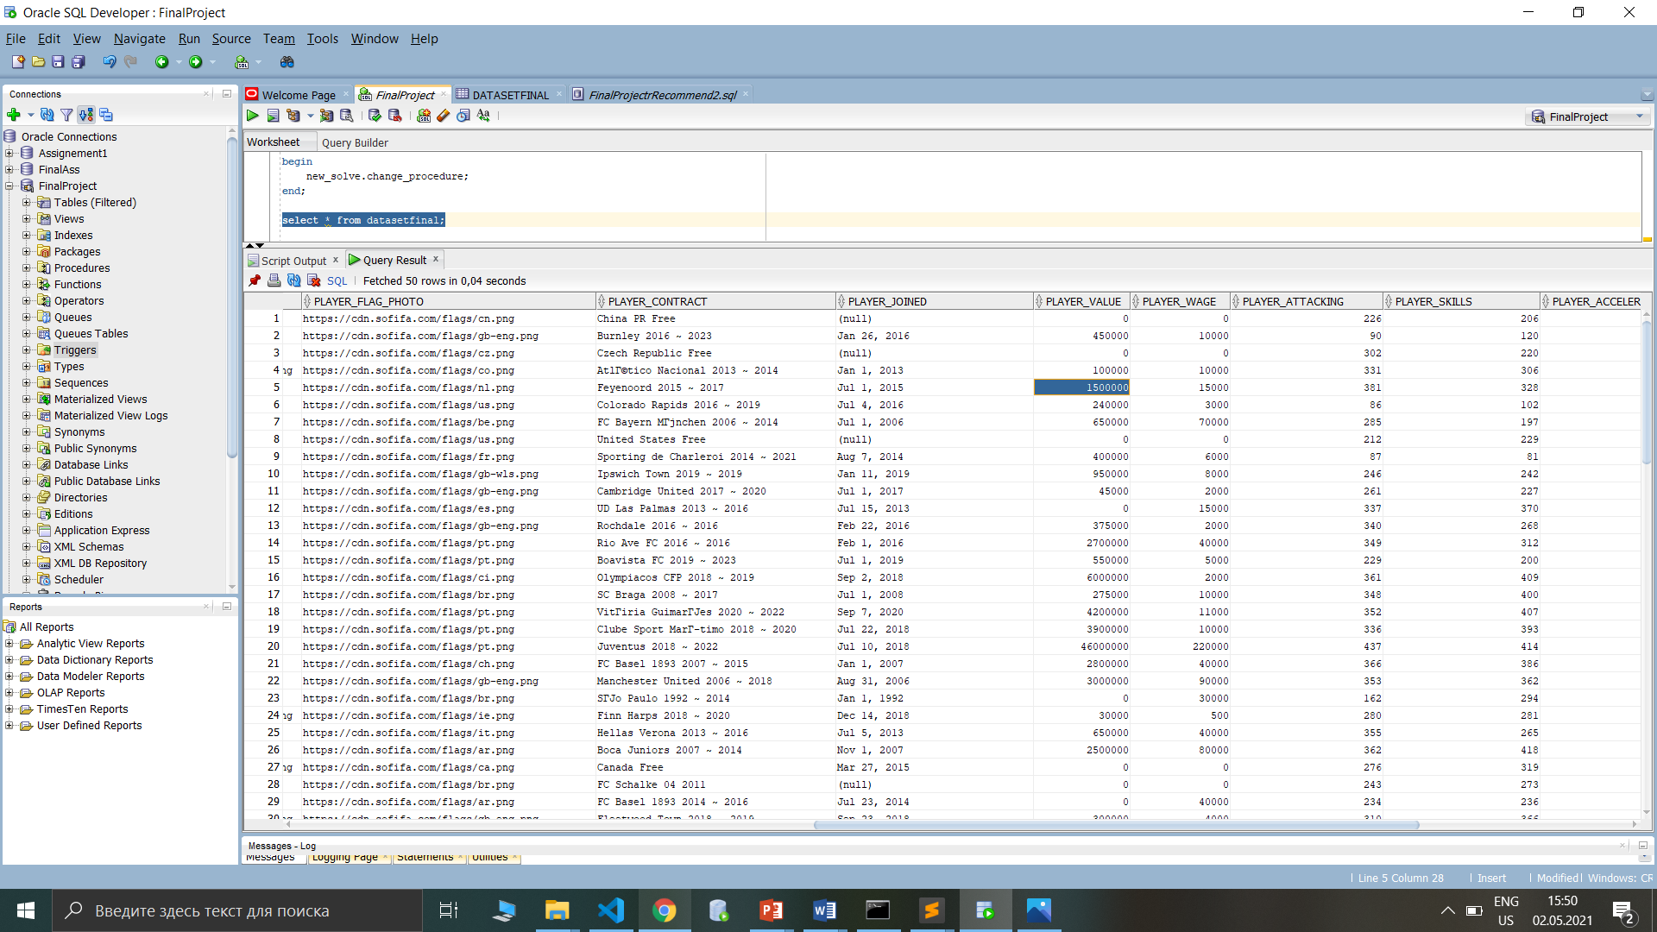

--RECOMMENDATION PROCEDURE TOP TEN PLAYERS BONUS PART

Create table recommendation_proc a s select * from datasetfinal;

Delete from datasetfinal;

create or replace procedure recommendation_proc

is

new_var number;

count_var number := 0;

cursor new_recommend is select * from datasetfinal

order by (player_overall_score + player_physics_overall) desc;

begin

delete from recommendation_table;

for i in new_recommend loop

insert into recommendation_table (player_id, player_name, player_age, player_nationality,player_club, player_contract, player_joined, player_value, player_wage, player_attacking, player_skills,player_acceleration, player_power, player_strength,

player_overall_score, player_physics_overall)

values(i.player_id,i.player_name, i.player_age, i.player_nationality,

i.player_club, i.player_contract, i.player_joined, i.player_value, i.player_wage, i.player_attacking, i.player_skills,

i.player_acceleration, i.player_power, i.player_strength,i.player_overall_score, i.player_physics_overall);

count_var := count_var + 1;

exit when count_var > 9;

end loop;

end;

RECOMMENDATION is essential part of our project. Because it is just for client convenience. We created special table for this one. Working principle is very easy. We select top ten players which have the highest points by computing PLAYER_OVERALL_SCORE and PLAYER_OVERALL_PHYSICS .Also it is already included in new_recommend cursor. Initially we delete all previous records from recommendation_table , then we insert data into recommendation_table by fetching records from cursor.

--THIRD TRIGGER FOR_RECOMMEND

create or replace trigger for_recommend

after insert or update or delete on datasetfinal

declare

v_var varchar2(5);

begin

if inserting then

recommendation_proc;

elsif updating then

recommendation_proc;

elsif deleting then

recommendation_proc;

else

v_var := 'no';

end if;

end;

For_recommend trigger is continuation of our bonus task. It is dependent on actions that will be done by manipulating datasetfinals table . So if you perform DML statement , it immediately changes records inside of recommendation_table which is logically correct.

